OVERSIGHT

Programmed by:

Sam Deutsch

ABOUT

Oversight is a tactical turn-based strategy game about constructing nuclear weapons and using them to annihilate your foes. Victory is achieved upon the complete destruction of all enemy cities. Similarly, the destruction of all allied cities will result in your defeat. Each player will have 3 minutes to issue orders to their troops. After all players have issued their orders the simulation will resume for 1 minute before starting the next order issuing phase.

USER INTERFACE

The user interface is made up of two components. The status bar:

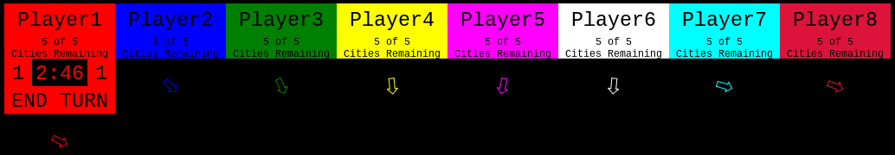

And the menu bar:

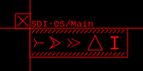

The status bar displays how many cities each player has, who’s turn it is to issue orders, and the amount of time left in that turn. The arrows will always point to where that player's cities are located. The player who has the timer and ‘END TURN’ button located beneath their name is currently issuing orders.

The menu bar has many different functions and is the primary way in which the player can interact with and issue orders to their troops.

START OVERSIGHT

First download **ALL** files and keep them all in the **same** folder. If you don’t do this the game will not start. OVERSIGHT should be started by double clicking on the ‘index.html’ file. The number of players, cities, and starting resources can be altered. To do this add a ? to the end of URL followed by one of these parameters:

* players
* cities
* resources

After the parameter add an = followed by a number greater than zero. Each parameter should be separated by the & symbol.

EXAMPLE URL:

http://example.com/index.html?players=4&cities=9&resources=500

This will start a game for 4 players, give each 9 cities and 500 starting resources.

THE MENU

The menu bar can be opened by clicking on any empty space within the simulation. The menu contains many sub menus for launching aircraft and missiles, constructing new weapons, and facilities, and arming nuclear weapons. In addition the menu cannot be moved while it is open, to close the menu click on the the ‘X’ in the top left of the menu bar or press the escape key.

The first icon in the ‘MAIN MENU’ Screenshot 2015-10-08 at 8.32.14 AM.png allows you to launch Interceptor jets which can be used to shoot down incoming bombers and missiles. The second icon Screenshot 2015-10-08 at 8.32.28 AM.png allows you to launch Long Range Nuclear Bombers, each equipped with 6 nuclear missiles. Both can be launched by clicking on their corresponding icon, then the air base from which to launch them Screenshot 2015-10-08 at 8.39.01 AM.png and then click on the destination you wish to send them. The third icon Screenshot 2015-10-08 at 8.32.34 AM.png allows you to launch InterContinental Ballistic Missiles (ICBM). These are launched in a similar manner to Interceptors and Bombers except they are launched from Silos. Screenshot 2015-10-08 at 8.44.17 AM.png

The first time you wish to launch any ICBMs or any Bombers you are required to enter and authenticate a random nuclear launch code. When attempting to launch a Bomber or ICBM you will be presented with the Authentication menu:

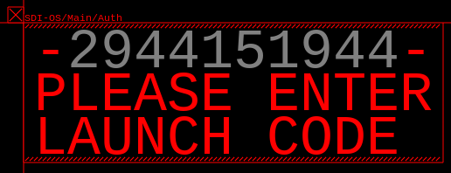

Enter the grey numbers using the number keys on the keyboard and the backspace key to erase the last number you entered. WARNING: Authenticating a launch codes is a time-consuming process that can take 1 to 2 minutes to complete. If the Authentication menu is closed or the round ends before the process can be completed you will be required complete it again.

The fourth icon Screenshot 2015-10-08 at 8.32.45 AM.png opens the fabrication sub-menu which can be used to construct additional aircraft, missiles, and facilities.

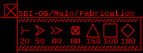

Each icon corresponds to a specific aircraft, missile, or facility. The number beneath each icon represents the amount of resources required to manufacture that aircraft or facility. To fabricate something, first click on the icon of the thing you wish to construct, then click on the factory Screenshot 2015-10-08 at 9.32.28 AM.png that you want to make the unit. After a solid green circle appears around the factory Screenshot 2015-10-08 at 9.33.10 AM.png you must click on a destination to send the unit.

Screenshot 2015-10-08 at 8.39.01 AM.png If you are constructing a Interceptor or Bomber your destination will be an Air Base.

Screenshot 2015-10-08 at 8.44.17 AM.png If you are constructing an ICBM your destination will be a Silo.

If you are constructing a Satellite, Factory, Air Base, or Silo you must construct it within one of the green dotted circles.

The last icon in the main menu Screenshot 2015-10-08 at 8.32.53 AM.png opens the preferences sub-menu which allows you to hide / display information about your units.

THE UNITS

There are 8 different units in OVERSIGHT each with very specific purposes and uses:

The Interceptor Screenshot 2015-10-08 at 8.32.14 AM.png is a short range attack fighter that specializes in shooting down incoming bombers and ICBMs. It will attempt to pursue and eliminate nearby enemies. If no enemies are nearby it will patrol randomly. If an Interceptor is low on fuel it will return to the air base it took off from to refuel.

The Long Range Bomber Screenshot 2015-10-08 at 8.32.28 AM.png is equipped with 6 short range tactical nuclear missiles. It is has a slow travel speed and is incapable of defending itself from enemy Interceptors. It will travel on a straight line to its destination and then reverse course back to the Air Base it took off from. The bomber will automatically attack any nearby enemy facilities.

The InterContinental Ballistic Missile (ICBM) Screenshot 2015-10-08 at 8.32.34 AM.png is a fast traveling nuclear missile that is launched from a Silo and has the same destructive force as the Long Range Bombers tactical nuke.

The Satellite  travels in an elliptical pattern and can shoot down near by nuclear missiles. The Satellite can only be destroyed if it gets caught in a nuclear blast.

Major Cities 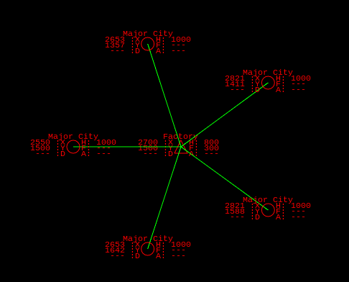 produce resources every round and send them to Factories automatically. Major Cities represent your health in this simulation and cannot be fabricated.

Factories Screenshot 2015-10-08 at 8.32.45 AM.png take resources generated by cities and convert them into aircraft, missiles, and facilities. WARNING: if all of your factories are destroyed you won’t be able to fabricate anything. Make sure to keep more than one around at all times.

Air Bases Screenshot 2015-10-08 at 8.39.01 AM.png store, launch, and refuel Interceptors and Bombers. Additionally if any enemy aircraft are detected by an Air Base it will automatically launch any Interceptors it has to attack them.

Silos Screenshot 2015-10-08 at 8.44.17 AM.png store and launch ICBMs and are heavily fortified to withstand some nuclear attacks.